**New York University Tandon School of Engineering**

Biomedical Engineering

Applied Mathematics and Statistics for Biomedical Engineering

Fall 2021

Professor Mirella Altoe

Tuesday 5:00-7:30PM Rogers Hall 325

# Computer Lab Assignment #3

**(2.5 pt.) QUESTION 1:** A seed randomly blows around a complex habitat. It may land on any of three different soil types: a high-quality soil that gives a 0.8 chance of seed survival, a medium-quality soil that gives a 0.3 chance of survival, and a low-quality soil that gives only a 0.1 chance of survival. These three soil types (high, medium, and low) are present in the habitat in proportions of 30:20:50, respectively. The probability that a seed lands on a particular soil type is proportional to the frequency of that type in the habitat.

1. **Draw a probability tree to determine the probabilities of survival under all possible circumstances. (1.5 pt.)**

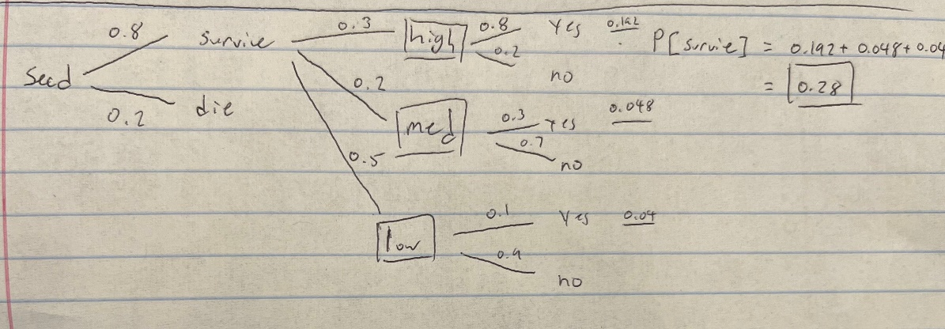

1. **What is the probability of survival of the seed, assuming that it lands? (0.5 pt.)**

Overall survival probability is 0.35, or 35%.

1. **Assume that the seed has a 0.2 chance of dying before it lands in a habitat. What is its overall probability of survival? (0.5 pt.)**

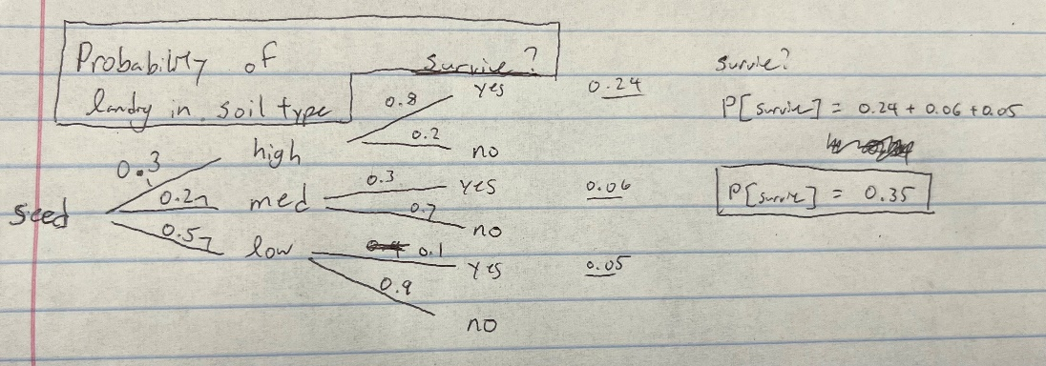

If the seed has a 20% chance of dying before it lands, then the overall survival rate will be 0.28 (or 28%).

**(0.5 pt.) QUESTION 2:** State the most appropriate null and alternative hypotheses for each of the following experiments or observational studies.

1. **A test of whether cigarette smoking causes lung cancer. (0.125 pt.)**
   1. Null: Cigarette smoking does not cause lung cancer.
   2. Alternative: Cigarette smoking causes lung cancer.
2. **An experiment to test whether mean herbivore damage to a genetically modified crop plant differs from that in the related unmodified crop. (0.125 pt.)**
   1. Null: Herbivore damage to a genetically modified crop plant does not differ from the related unmodified crop.
   2. Alternative: Herbivore damage to a genetically modified crop plant differs from that in a related unmodified crop.
3. **A test of whether industrial effluents from a factory into the Mississippi River are affecting fish densities downstream. (0.125 pt.)**
   1. Null: Industrial effluents from a factory into the Mississippi River are not affecting fish densities downstream.
   2. Alternative: Industrial effluents from a factrory in to the Mississippi River are affecting densities downstream.
4. **A test of whether providing municipal safe-injection sites for drug addicts influences the rate of HIV transmission. (0.125 pt.)**
   1. Null: Municipal safe-injection sites for drug addicts does not influences the rate of HIV transmission.
   2. Alternative: Municipal safe-injection sites for drug addicts influences the rate of HIV transmission.

**(1.0 pt.) QUESTION 3:** Tikal National Park in Guatemala is heavily visited by tourists. Does the disturbance affect animal densities? To investigate, Hidinger (1996) compared the densities of various bird and mammal species in places immediately next to heavily visited ruins to places in the park that were rarely visited by tourists. The mean densities (in animals/km2) are found in the accompanying table. The table also lists the *P*-value associated with a test of the null hypothesis that the two types of plots do not differ in mean density.

1. **Which species show a statistically significant reduction in mean density near heavily visited ruins? Use a significance level of α = 0.05. (0.5 pt.)**

Crested Guan, Great Curassow, Tinamou.

1. **Which species show a significant increase in density near heavily visited ruins? (0.25 pt.)**

Agouti, Coatimundi, Howler Monkey, Ocellated Turkey

1. **Which species provide no significant evidence of a difference in mean density between areas frequented by tourists and those rarely visited? (0.25 pt.)**

Collared Peccary, Deppes Squirrel, Spider Monkey,

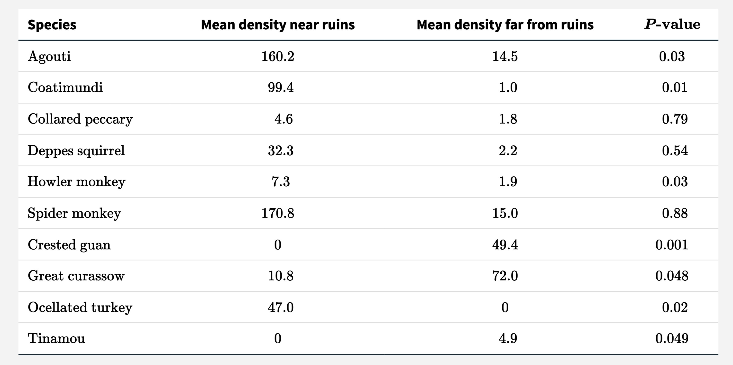

**(EXTRA) QUESTION 4:** Imagine that two researchers independently carry out clinical trials to test the same null hypothesis, that COX-2 selective inhibitors (which are used to treat arthritis) have no effect on the risk of cardiac arrest. They use the same population for their study, but one experimenter uses a sample size of 60 participants, whereas the other uses a sample size of 100. Assume that all other aspects of the studies, including significance levels, are the same between the two studies.

1. **Which study has the higher probability of a Type II error, the 60-participant study or the 100-participant study? (0.25 pt.)**

The 60 participant study is more likely to have a Type II error because they are more likely to occur when the sample size is too small.

1. **Which study has higher power? (0.25 pt.)**

The 100-participant study has a higher power (this means that the probability of rejecting a false null hypothesis when a random sample is taken from a population).

1. **Which study has the higher probability of a Type I error? (0.25 pt.)**

Sample size does not affect the probability of a Type I error.

1. **Should the tests be one-tailed or two-tailed? Explain. (0.25 pt.)**

This test should be a one-tailed. The researchers are trying to determine if COX-2 inhibitor has a effect on the risk of arthritis.